SPARK: Simple Play Adaptations to Reference for Kids

Buddy Button Switch
Description: | Image:
The Buddy Button is a mechanical wired single switch that requires only the slightest touch of its 2.5-in/6.4-cm surface for activation. It can be activated by almost any body part such as the hand, elbow, shoulder, head, etc. Buddy Buttons are commonly used as external inputs for speech generating devices (SGDs), computers and mobile devices, switch adapted toys, and a variety of other electronic and battery operated devices. However, depending upon the device and function of the device an additional switch interface may be needed between the switch and the device. The Buddy Button can be plugged directly into most switch adapted toys and other devices that have a standard, mono 3.5mm switch jack and have a simple on/off function. | 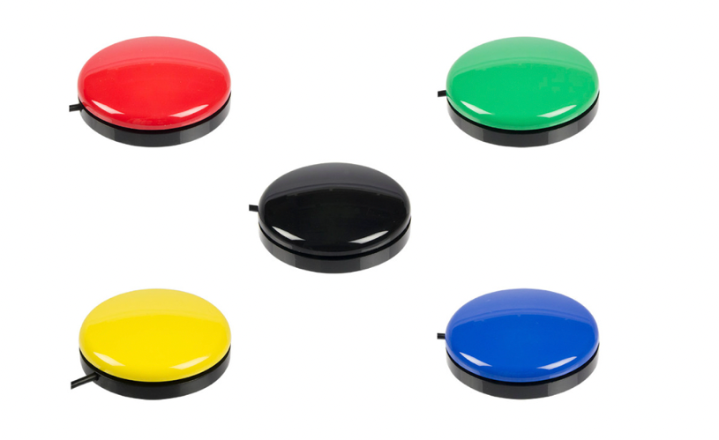  Purchasing Information  Demo Video  Buddy Button Quick Start Guide

Who Might Benefit?
Those who have significant motor challenges who need...
• an alternate form of access to engage in activities associated with computers, mobile devices, speech generating devices, adapted toys and other electronic and battery-operated devices (small kitchen appliances, fans, lights, etc.).

• a way to access and engage in typical childhood activities that may be simulated through electronic means (play a board game, read a picture book, create art, listen to music, play with cars, cut with scissors, etc.).

Why Use?
Provides an opportunity to…
• Access and engage with a variety of battery-operated and electronic devices that are not accessible in the usual way to the child.

• Access and engage in typical childhood activities through adapted electronic means.

Instructions for Use: | Adaptation Ideas:
Environmental Considerations  - Use in most environments. Although extremely durable, they have electronic parts and mechanical features it is probably best to avoid environments where the Buddy Button would be submerged in water or be placed directly in dirt or sand.  Positioning  - Place on a flat surface or Velcro onto any surface where it can be securely attached and can be activated without moving away from the child. (e.g. table top, floor, wheelchair tray, wall, etc.). Variables to consider are 1). the distance of the switch cable that runs from the switch port of the device to the switch and 2). the positioning of the child to the activity and the switch so they can see and hear the activity and reach the switch for activation.  Alternate Positioning  - Alternate positioning of the switch is needed the OCALI lending library offers a variety of articulating switch mounting systems that can be positioned in a variety of ways. The switch is then mounted to the arm and the arm can be mounted to a table or child’s seating system.  Basic Play/Use  Intended to be an interface between the child and an activity. The focus and emphasis should never be about the switch, but rather directing the child attention to the activity the switch activates. (e.g. move the car, play the music, start the scissors, etc). In the initial phase of introducing a switch to a child rather than tell the child to “press the switch”, instead say “press the switch to play the music” As the child begins to understand and learn the cause and effect of pressing the switch to play the music, the directions should become simply “play the music”. The child will understand that pressing the switch is their way to play the music much like other children who do not use a switch understand that pushing a button on an mp3 player will play the music.  - Toys and devices that already have a single mono 3.5mm switch jack port and a simple on off function are the most simplistic ways to use a switch. The Buddy Button can be plugged directly into the switch port of the device with the switch jack.  Extended Play/Use  - Some activities require that the child maintain pressure on the switch for the activity to continue. If the child is unable to maintain continuous pressure on the switch, a switch latch timer could be used to setup the switch so the child need only depress the switch once to start the activity. The activity would continue until the switch was depressed again by the child. The OCALI lending library has switch latch timers that can be loaned to make this simple adaptation. They can be found in the Switch Connection Kit.  - If you wish to run an electrical appliance with a switch such as a fan, hairdryer, blender, an electrical switch interface will be needed between the device and switch such as the Powerlink . This device can also be requested from the OCALI Lending library.  - Some devices need switch interfaces to send the correct switch functions to the device. These devices are typically used with electronic devices and require a USB connection such as computers and mobile devices. Switch interfaces can also be found in the OCALI lending library for loan through the Switch Connection Kit that allow switches to be used with these types of devices and switch accessible software.  - If you wish to learn more about how switches can provide access for children with significant motor challenges go to the OCALI Assistive Technology Internet Modules: Switch Access - WATI - Part I and Switch Access - WATI - Part II which will describe in more detail how to assess the need for, setup, and use switches for a variety of access needs.  Play/Use with Others  - The use of multiple switches can allow multiple players to do various parts of an activity based on the software used for the activity or if the switch adapted device has multiple switch ports and functions.  Words to Encourage Play/Use  - These words would be primarily dependent on the activity the switch is activating.  - Additional words might be press, release, and hold while the child is initially learning the function of the switch. | Optional Additional Materials/Supplies  - Velcro  - Dycem, non-skid matting, cabinet liner  Build It Up  - Put the switch inside a 3-ring binder notebook to add a bigger surface to activate.  Stabilize It  - Stabilize to a table surface or the floor using velcro.  - Use of a switch mounting system could also provide improved stabilization of the switch.  Add Sensory Cues  - Add puffy stickers, puffy paints, different textures to the switch.  - The color of the switch could also be changed.  - A picture symbol could be added to the switch to indicate that pushing the switch activates a specific activity (bubbles, fan, hair dryer, music, etc.).  Alternative Uses  - Different types of switches could be trialed if the included switches are not usable by the child. The OCALI lending library has several kits with multiple types of switches that can be trialed.  DIY Alternatives Uses  - Use a battery interrupter to quickly switch-adapt a standard battery operated toy that does not have a switch port, but has a specific on/off function. The video describes how make this adaptation. (Note: the battery interrupter needed is specific to the size of the battery in the device).

*”Adaptations” adapted from: Haugen’s Modes for Adapting Toys based on materials from the "Let's Play" Project at the University of Buffalo
PCS is a trademark of Tobii Dynavox, LLC. All rights reserved. Used with permission.

